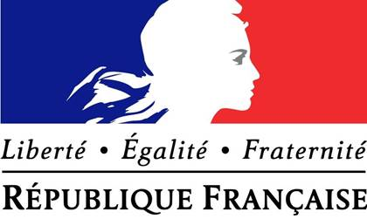

**LOOKING BEYOND 2020:**

Strengthening the

ACP-EU Partnership

__________________

**Asia-Pacific Model European Union 2018**

**18 May 2018**

1. **Introduction**

Since the beginning, France has endeavoured to foster closer ties between the EU and the ACP by advocating for various trade and development programmes. As the Cotonou Agreement is set to expire in 2020, France maintains that the ACP-EU partnership continues to be of vital importance and affirms its commitment to renewing this partnership.

* 1. **The value of an ACP-EU partnership**

The Lisbon Treaty laid out a compelling vision for the EU to become a more efficient and powerful actor on a global scale. Such capabilities would enable the Union to fulfil its global responsibilities as laid out in the EU’s Global Strategy, especially since it is the world’s foremost civilian power. Therefore, the EU should commit to a strong ACP-EU partnership that promotes human development and strengthens effective multilateralism in the region.

Moreover, the challenges of the world are becoming increasingly global and multifaceted in nature. No country would be able to unilaterally tackle these threats. Partnership with the ACP grouping of countries will allow for extensive cooperation across three continents to tackle the various problems at hand. Hence, there continues to be value in the continent-to-continent approach that has characterised the ACP-EU partnership. The EU should deepen its cooperation with other regional and international organisations alongside this partnership so as to promote coherence and eliminate duplication.

* 1. **French support for a regional yet differentiated approach**

France is strongly supportive of a deep and ambitious ACP-EU partnership that unites the two regions. Multilateralism in recent years has been facing headwinds in the form of economic protectionism and ardent nationalism. As such, it is ever more important that the partnership retains the continent-to-continent approach that has brought the 27 EU member states and 78 ACP countries together in regular dialogue and cooperation.

At the same time, in order to deepen the effectiveness of European cooperation and assistance, it has become increasingly necessary to tailor the approach according to the needs of disparate ACP groupings and countries. This regional yet differentiated approach is at the heart of the 2030 Agenda for Sustainable Development, which pairs regionalism with national responsibility.

* 1. **The situation as it pertains to France**

France acknowledges that this partnership has historically fallen short of expectations in some areas. In addition, it notes that the current global situation has presented new challenges that confront both the ACP and EU. Hence, France argues that the new partnership agreement should embody two main principles: first, the new framework that governs the ACP-EU relationship must ensure *substantive* joint ownership and leadership of development goals. Second, the new framework should shift its focus from the current market- and trade-centred approach to one that centres on human development. To that end it proposes the following policies:

1. **Policy Proposals**
   1. **Post-Cotonou EU-ACP Partnership: A Tiered Institutional Arrangement**

On 25 April 2018, in a speech before the United States Congress, President Macron affirmed the indispensable role of multilateral institutions (such as the ACP-EU partnership) in ‘fac[ing] together the global challenges of this century’. France also recognises that each region and nation confronts its own separate, unique challenges. Therefore, we should create an ACP-EU framework that is flexible enough to accommodate joint action on one hand and allow Member States to tackle region- or nation-specific issues on the other.

France proposes a tiered institutional arrangement in the renewed partnership agreement under an overall ACP-EU umbrella (see Figure 1):

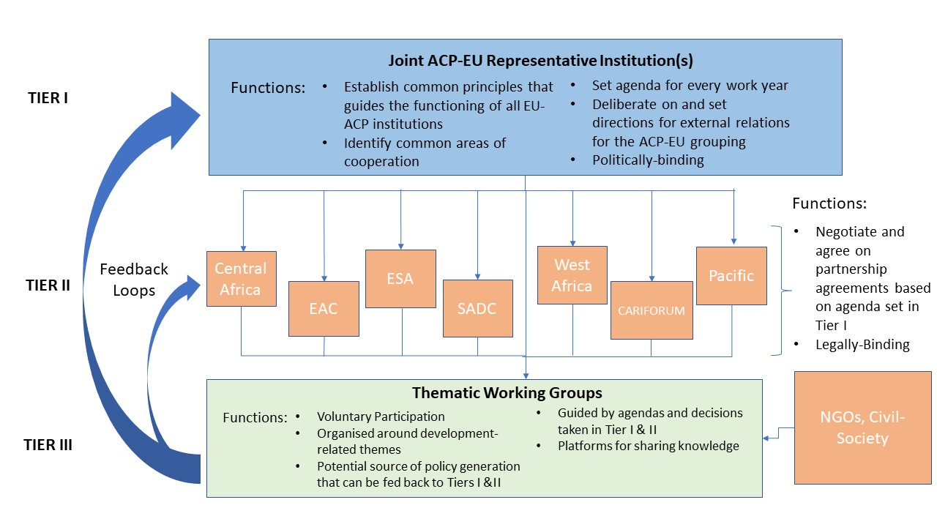

Figure 1 - Tiered Representation within the ACP-EU Umbrella

The goal at Tier I is to allow broad, inclusive, joint political participation and representation of all Member States within the ACP-EU framework through the creation of politically-binding agreements. The functions of Tier 1 include:

* Establishing common principles that guide the functioning of the ACP-EU as a whole
* Identifying broad common policy goals members wish to pursue
* Setting the agenda for the work year for at Tiers II and III
* Setting directions for the external relations of ACP-EU

Tier I will be broadly comparable to the EU’s own European Council. Decisions made here will set the agenda and tenor of work done at Tier II and Tier III. Judging by the EU’s own experience, such an arrangement is not only plausible but potentially effective.

In the PNG Summit Waigani Communiqué, ACP Members affirmed the need for a partnership based on a ‘legally-binding framework’. Given that the EU shares the same view, France proposes for formal, legally-binding partnership agreements to be negotiated on a region-to-region basis at Tier II, according to their EPA grouping.

Finally, France envisions thematic working groups to be established at Tier III that are dedicated to specific development-related themes, such as climate change and public health, with reference to the agenda set at Tier I. Since the concerns of ACP Members are varied, participation by ACP Members will be voluntary, enabling them to adjust their commitments as they see fit. These groups are intended to be platforms where Members share knowledge and best practices, and engage in policy discussions. Tier III opens up the possibility of participation by NGOs and civil society, thus widening knowledge pools and enriching discussions. Tier III may also present opportunities for policy generation that can be fed back to the previous tiers.

France believes the above arrangement is mutually beneficial: for ACP states, given that the ACP grouping is so broadly conceived, it will ensure that agreements will address concerns that may be more specific to their situation. For the EU, it can target resources where they can make the greatest impact.

With regards to parallel frameworks, France believes that they do not detract from a new partnership agreement as the ambit of this partnership will be much more expansive compared to these frameworks. As such, different parallel initiatives will not undermine the value of the new agreement.

* 1. **Shifting the EU Development Strategy**

As the Council presidency has noted, the EU is the leading donor of ODA. According to the OECD, as of 2014, ODA constitutes ‘more than 70% of net external flows and the equivalent of 40% of tax revenue’ in LDCs. Consequently, France acknowledges the role of ODA within the European development strategy.

In 2005, the Commission introduced new regulations to increase the effectiveness of ODA, aiming to:

* Encourage leadership and ownership of development programmes in recipient countries
* Increase transparency and accountability for both donor and recipients
* Increase cost efficiency
* Raise awareness in recipients about what funds and when they will receive

Accordingly, France supports ‘budgetisation’ as it will contribute to these objectives, particularly in terms of transparency and accountability. Nevertheless, France holds the position that ODA is a necessary but *insufficient* component in achieving the EU’s overall developmental goals.

However, France is concerned about these EU developmental goals as it believes that the EU is employing two competing developmental strategies concurrently. France calls attention to the following:

* On one hand, the EU encourages development in the various Economic Partnership Agreements through market liberalisation and trade. Consequently, it requires governments to deregulate the market and liberalise their economic agendas.
* On the other hand, the EU also wishes to achieve development through human development strategies, requiring government action and stated interventions. In 2011, the EU adopted the Agenda for Change - amongst its goals is commitment to action toward human development goals such as ‘social protection, health and education’. Furthermore, the 2016 Joint Communication on Renewing the ACP-EU Partnership proposes a framework premised on SDGs laid out in the UN 2030 Agenda.

France holds the position that these two developmental strategies are not necessarily mutually exclusive nor contradictory in nature. However, pursuing these approaches simultaneously may generate incoherence for both sides. Thus, France believes that committing to *both* strategies at the same time may dampen the effectiveness of the EU’s overall development strategy.

With regard to France’s own position, while it continues to affirm the importance of market-based approaches and EPAs in development, it believes that an approach centred on human development should constitute the dominant strategy for development for two reasons: first, we know that a trade- and market-driven strategy alone does not work. As the presidency notes, ‘positive development remains patchy’. Second, other international development actors have also acknowledged its limitations. This is why the World Bank’s current strategy aims at poverty reduction and includes strategies like developing social market frameworks. Similarly, the UN has also pushed for a human development focus with MDGs and subsequently, SDGs.

Finally, France believes that the ACP-EU should prioritise climate action in its development goals. The recent withdrawal of the US from the Paris Climate Agreement represents a major setback and has heightened the global community’s sense of urgency in tackling this challenge. In addition, France and its fellow EU and ACP partners are facing serious threats from climate change, particularly in our agricultural sectors. In sub-Saharan Africa, for instance, the agricultural sector contributed 12.7% to the total GDP and provided employment to 60% of the workforce in 2009, according to the OECD. Moreover, Caribbean and Pacific countries are particularly vulnerable to rising sea levels caused by climate change.