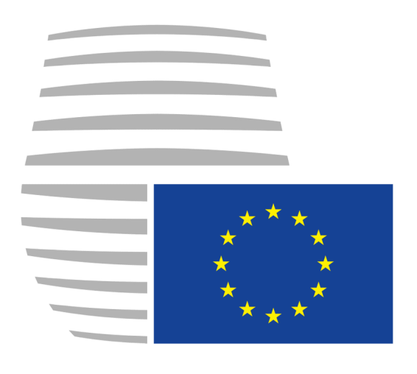 EUROPEAN COUNCIL 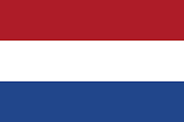

POSITION PAPER

From Delegation of the Netherlands

Delegates: Liang Jie, Cao Chenchen

To: President of European Council

Topic:

1. The future of genuine European Defense Community devised as an institution responsible for Europe’s security based on the Lisbon Treaty.
2. The creation of European Army that would report and be deployed by the European Union.

**Introduction**

The first proposal of setting up Permanent Structured Cooperation on security and defense (PESCO) was put forward on 13 November 2017, then the Ministers signed a common notification on the PESCO and handed it to the High Representative and the Council. The notification lists 20 binding common commitments in the areas of defense investment, capability development and operational readiness. It also contains proposals for PESCO governance and its principles.

On 11 December 2017, from the foundation of the notification, the Council took the historic step to adopt a decision establishing PESCO and the list of participants. The total of 25 Member States decided to participate in PESCO.

On 6 March 2018, the Council adopted a Recommendation which set out a roadmap for the further implementation of PESCO.

On 25 June 2018, the Council adopted a Decision establishing the common set of governance rules for the PESCO projects. Every year, it would generate new projects, not only the member states, but also the third states may exceptionally participate at the level of PESCO projects. The Council would agree on the general conditions under which third states may exceptionally be invited to participate in PESCO projects.

From the one report of the European Union External Action in 2018, “in light of a changing security environment, the EU Global Strategy for Foreign and Security Policy (EUGS) started a process of closer cooperation in security and defense. The EU Member States agreed to step up the European Union’s work in this area and acknowledged that enhanced coordination, increased investment in defense and cooperation in developing defense capabilities are key requirements to achieve it.” (Team, 2018) And it is also the main aim of a Permanent Structured Cooperation (PESCO) on security and defense. PESCO was set as the outline in the Treaty of the EU, Articles 42(6) and 46, as well as Protocol 10. From the EU opinions, through PESCO, Member States can increase their effectiveness in addressing security challenges and advancing towards further integrating and strengthening defense cooperation within the EU framework.

The difference between PESCO and other forms of cooperation is that the commitments made by participating member states are legally binding. The decision to participate is voluntarily made by each participating member country and the decision will be taken by the participating member states. This does not hinder the specific characteristics of the security and defense policies of certain EU member states.

**The Dutch perspective**

There are more and more challenges and risks all over the world, as the former High Representative for the Common Foreign and Security Policy of the European Union, pointed out in 2003, that the threats become more diffuse, they are, particular, “terrorism, the proliferation of weapons of mass destruction, regional crises, failing states and organized crime.” Also, within the Europe, the exists conflicts and even wars, the Crimea war explores the uncertainty of the Europe. For more than half a century, the Europe has relied much on NATO in defence, which is led by the United States of America. After Donald Trump came into power in 2017, he shifted the foreign policy into “America first” and focused on domestic affairs. As a result, the Trump government deemphasized the importance of NATO and required the European countries to increase the military expenditure, since the US has always been the biggest contributor to NATO, which Trump believed to be a burden. Therefore, a stronger Europe with powerful military force is in urgent need.

Geographically, the Netherlands is in the middle of the Germany, France and the UK, with no terrain to attack or retreat in the land. While on the sea, there are no powerful coastal defence construction compared with the UK. The military power of the Netherlands is relatively weak.

Politically, The Netherlands has always been supportive to strengthen the European defence capabilities.

The founding of PESCO is a significant means to improve the military power of the Europe and also to reduce the stress from the US. During the Netherlands EU presidency in the first semester in 2016, there were a series of high-level seminars held to discuss the issues in the area of the EU defence. With regard to PESCO, the Netherlands was one of the four countries supporting the Franco-German-Italian-Spanish paper of July 2017 to support the founding of PESCO.

Therefore, it is of great significance for the Netherlands to support and participate actively in PESCO in order to strengthen the military power of the Europe, which fits the interest of the Netherlands and the EU. By doing so, the security of the Netherlands can be guaranteed and the Europe will keep safe.

As the Netherlands declared in the Letter to Parliament ahead of the November 2017 Council meeting, PESCO is a means to strengthen the European military power and to form a more united defence policy (Zandee, 2018). Since it is a means, the success of PESCO must be evaluated by outcomes. Therefore, there must be “concrete outcomes”. It is not a duplication of NATO. In other words, PESCO is created only for the improvement of EU military capabilities and at the same time, the outcome from PESCO should contribute to NATO in order to reduce the stress from the US.

As to the European Army, it is a goal that cannot be reached in recent years. Only when we make full preparation under the framework of PESCO, can we start to build a dependent European Army. At present, PESCO is only a means to improve the military power. Things should be done step by step. The Netherlands does not rule out the possibility of the creation of the European Army, in fact, PESCO may be the harbinger of the European Army. However, what the Netherlands think the most important thing is to make some achievements through PESCO.

**Solutions**

1. **Further implementing the Military Mobility Project.** The Military Mobility Project aims for the simplification and standardization of the military transfer procedures among countries. The project would reduce the barriers and long bureaucratic procedures within governments, which can significantly improve the efficiency.

2. **Allowing the participation of third countries.** In order to involve more European countries into PESCO to secure the Europe altogether, the project should allow third countries who are not within the EU to join, for example, Norway and the UK. Though they are not EU countries, they still have a say in the European security affairs since the peace in the Europe needs every country’s effort. Once these third countries join PESCO, the military power would be further improved and so as the military budget.

3. **Launching more research projects of European Defence Found (EDF), raising the standard of budget.** By doing so, member states would significantly improve their military expenditure.EDF is primarily used as a tool to provide funding for the Dutch Defence Technology and Industrial Base (DTIB). The main interest is not to address the lack of capacity in Europe, but to participate in cross-border industrial development and procurement programs. The use of EDF funds outside the PESCO can provide more room for an industry-driven approach, although the committee process for approving the work plan will give Member States an opportunity to intervene (ZANDEE, 2018).

**Reference**

Raad Algemene Zaken en Raad Buitenlandse Zaken, Brief van de minister van Buitenlandse Zaken aan de Voorzitter van de Tweede Kamer van de Staten-Generaal, Den Haag, 3 november 2017, Kamerstuk 21 505-02, Nr. 1793. (translation into English by Dick Zandee).

Team, EEAS Press. (2018). *Permanent Structured Cooperation (PESCO) - Factsheet*. European Union External Action. Retrieved from

<http://eeas.europa.eu/sites/eesa/files/pesco_factsheet_november_2018_en_0.pdf>.

Solana, J. (2003). A secure Europe in a better world: European security strategy. içinde Klaus Schilder ve Tobias Hauschild, der., Civilian Perspective or Security Strategy.

Zandee, D. (2018). PESCO: The Dutch Perspective. Armament Industry European Research Group. Retrieved from <https://www.clingendael.org/sites/default/files/2018-09/PeSCo_Dutch_Perspective_DZ_Ares-28.pdf>